
Compsoft Technologies
Bangalore,Karnataka

AN INTERNSHIP REPORT ON

“ LEAF NOW ”

BACHELOR OF ENGINEERING
In

COMPUTER SCIENCE AND ENGINEERING

Submitted by: RESHMA S (1KN19CS084)

MUSKAN B(1KN19CS062)

Under the Supervision of: Sumukh S Jadhav


SApthAgiri College of Engineering(college name sample)
(Affiliated to Visvesvaraya Technological University and Approved by AICTE, New Delhi)Accredited By NAAC with ‘A’ Grade
ISO 9001-2015 and 14001-2015 certified Institute

BengAluru, KArnAtAkA 560057

2020-2021

ABOUT THE COMPANY

CST is a digital service provider that aims to provide software, designing and marketing solutions to individuals and businesses. At CST , we believe that service and quality is the key to success
We provide all kinds of technological and designing solutions from Billing Software to Web Designs or any custom demand that you may have. Experience the service like none other!

Some of our services include:
- Development - We develop responsive, functional and super-fast websites.
- We keep User Experience in mind while creating websites. A website should load quickly and shouldbe accessible even on a small view-port and slow internet connection.
- Mobile Application - We offer a wide range of professional Android, iOS& Hybrid app development services for our global clients, from a start up to a large enterprise.
- Design - We offer professional Graphic design, Brochure design & Logo design. We are expertsin crafting visual content to convey the right message to the customers.
- Consultancy - We are here to provide you with expert advice on your design and development requirement.
- Videos - We create a polished professional video that impresses your audience.

Table of Contents

Contents Page No.

Table of Contents I
Overview of the project 1
About 2
Tools used 3
Implementation 4-25
Snapshots 26-27
Biblography 28

(I)

OVERVIEW OF THE PROJECT

Project Name: LEAF NOW BUILD
Team Members: RESHMA S
MUSKAN B

OVERVIEW OVERVIEW

Ever since industrialisation started the care for plants has made it to our least priority
list, Even though mankind requires plants to balance the food chain that he’s a part of,
but the plant enthusiasts are everywhere, be it big metropolitan cities or rural areas,
so we aim to bring in a platform that can connect these plant/nature enthusiasts and
help them exchange/sell them plants or donate seeds/plants as part of the green
initiative that we started 2 years back.

Key details on LEAF NOW:

The most crucial feature of LEAF NOW is connecting enthusiasts, which means that
users should be able to create an account on the site and can start filling out a form
to submit their services, which will later be published by our team if it is genuine
The second feature is encouraging users to sell/buy/donate plants/seeds, by
letting them know the importance of the same
The third important feature is the discussion page, which sets up a discussion
page for the enthusiasts to start a discussion on topics that they like (optional)
A pdf for every donation, a donation can be money(1rs for every plant) requires you
to convert web content to pdf encouraging other users to do the same.

PROJECT NAME : LEAF NOW BUILD

Grow in average, medium moisture, well-drained soil in part shade to full shade. Prefers rich, moist, humusy soils
. Often forms large colonies in the wild. Will self-seed under optimum growing conditions.
As with many of the early spring wildflowers, Mayapple goes dormant in summer.
The Department of Agriculture and Co-operation is implementing a Central Sector Scheme as ‘Development and Strengthening
of Infrastructure Facilities for Production and Distribution of Quality Seeds’ since 2005-06 for the whole country.
The objective of the ongoing scheme is to ensure production and multiplication of high yielding certified/quality seeds of all crops in sufficient quantities
and make the seeds available to farmers, including those in remote areas, not easily accessible by rail/road on time and at affordable price.

Project Na

Detailed understanding of the concept of the Project to be written here

TOOLS USED

Software Requirements

  - Visual Studio Code 2019.

  - Google Chrome or Microsoft Edge of latest version.

  - Front End: HTML, CSS, JS

  - Backend : Php, MySQL, Xampp

  - Linux 7.1 or Windows XP/7/8/10 OS or Mac OS

Hardware Requirements

  - Pentium 200-MHz computer with a minimum of 64 MB of RAM (128 MB of RAM recommended).
  - Monitor with a refresh rate of at least 40Hz for a smooth GUI experience (optional).

IMPLEMENTATION

<Please paste your complete source code ><!DOCTYPE html><!DOCTYPE html>
<html lang="en">
<head>
<meta charset="UTF-8">
<meta name="viewport" content="width=device-width, initial-scale=1.0">
<title>complete responsive plant selling website design tutorial</title>

<link rel="stylesheet" href="https://unpkg.com/swiper/swiper-bundle.min.css" />

<!-- font awesome cdn link -->
<link rel="stylesheet" href="https://cdnjs.cloudflare.com/ajax/libs/font-awesome/5.15.3/css/all.min.css">

<!-- custom css file link -->
<link rel="stylesheet" href="/plant website/style.css">

</head>
<body>

<!-- header section starts -->

<header>

<div class="header-1">

<div class="share">
<span> follow us : </span>
<a href="#" class="fab fa-facebook-f"></a>
<a href="#" class="fab fa-twitter"></a>
<a href="#" class="fab fa-instagram"></a>
<a href="#" class="fab fa-linkedin"></a>
</div>

<div class="call">
<span> call us : </span>
<a href="#">+123-456-7890</a>
</div>

</div>

<div class="header-2">

<a href="#" class="logo"> <i class="fas fa-seedling"></i> LEAF NOW </a>

<form action="" class="search-bar-container">
<input type="search" id="search-bar" placeholder="search here...">
<label for="search-bar" class="fas fa-search"></label>
</form>

</div>

<div class="header-3">

<div id="menu-bar" class="fas fa-bars"></div>

<nav class="navbar">
<a href="#home">home</a>
<a href="#category">category</a>
<a href="#product">product</a>
<a href="#deal">deal</a>
<a href="#contact">contact</a>
</nav>

<div class="icons">
<a href="#" class="fas fa-shopping-cart"></a>
<a href="#" class="fas fa-heart"></a>
<a href="/plant website/Form.html" class="fas fa-user-circle"></a>
</div>

</div>

</header>

<!-- header section ends -->

<!-- home section starts -->

<section class="home" id="home">

<div class="swiper-container home-slider">

<div class="swiper-wrapper">

<div class="swiper-slide">
<div class="box" style="background: url(images/slider1.jpg);">
<div class="content">
<span>upto 75% off</span>
<h3>plant big sale special offer</h3>
<a href="#" class="btn">shop now</a>
</div>
</div>
</div>
<div class="swiper-slide">
<div class="box" style="background: url(images/slider2.jpg);">
<div class="content">
<span>upto 45% off</span>
<h3>plant make people happy</h3>
<a href="#" class="btn">shop now</a>
</div>
</div>
</div>
<div class="swiper-slide">
<div class="box" style="background: url(images/slider3.jpg);">
<div class="content">
<span>upto 65% off</span>
<h3>decorate your home now</h3>
<a href="#" class="btn">shop now</a>
</div>
</div>
</div>

</div>

<div class="swiper-pagination"></div>

</div>

</section>

<!-- home section ends -->

<!-- banner section starts -->

<section class="banner-container">

<div class="banner">
<img src="images/banner1.jpg" alt="">
<div class="content">
<span>new arrivals</span>
<h3>house plants</h3>
<a href="#" class="btn">shop now</a>
</div>
</div>
<div class="banner">
<img src="images/banner2.jpg" alt="">
<div class="content">
<span>new arrivals</span>
<h3>office plants</h3>
<a href="#" class="btn">shop now</a>
</div>
</div>

</section>

<!-- banner section ends -->

<!-- category section starts -->

<section class="category" id="category">

<h1 class="heading"> shop by category </h1>

<div class="box-container">

<div class="box">
<img src="images/cat1.jpg" alt="">
<div class="content">
<h3>bonsai</h3>
<a href="#" class="btn">shop now</a>
</div>
</div>
<div class="box">
<img src="images/cat2.jpg" alt="">
<div class="content">
<h3>plants for house</h3>
<a href="#" class="btn">shop now</a>
</div>
</div>
<div class="box">
<img src="images/cat3.jpg" alt="">
<div class="content">
<h3>plants for office</h3>
<a href="#" class="btn">shop now</a>
</div>
</div>
<div class="box">
<img src="images/cat4.jpg" alt="">
<div class="content">
<h3>gift plants</h3>
<a href="#" class="btn">shop now</a>
</div>
</div>

</div>

</section>

<!-- category section ends -->

<!-- product section starts -->

<section class="product" id="product">

<h1 class="heading"> new products </h1>

<div class="box-container">

<div class="box">
<span class="discount">-10%</span>
<div class="icons">
<a href="#" class="fas fa-heart"></a>
<a href="#" class="fas fa-share"></a>
<a href="#" class="fas fa-eye"></a>
</div>
<img src="images/product1.jpg" alt="">
<h3>latest plants</h3>
<div class="stars">
<i class="fas fa-star"></i>
<i class="fas fa-star"></i>
<i class="fas fa-star"></i>
<i class="fas fa-star"></i>
<i class="far fa-star"></i>
</div>
<div class="quantity">
<span> quantity : </span>
<input type="number" min="1" max="100" value="1">
</div>
<div class="price">80.00 Rs<span>120.00 Rs</span></div>
<a href="#" class="btn">add to cart</a>
</div>

<div class="box">
<span class="discount">-25%</span>
<div class="icons">
<a href="#" class="fas fa-heart"></a>
<a href="#" class="fas fa-share"></a>
<a href="#" class="fas fa-eye"></a>
</div>
<img src="images/product2.jpg" alt="">
<h3>latest plants</h3>
<div class="stars">
<i class="fas fa-star"></i>
<i class="fas fa-star"></i>
<i class="fas fa-star"></i>
<i class="fas fa-star"></i>
<i class="far fa-star"></i>
</div>
<div class="quantity">
<span> quantity : </span>
<input type="number" min="1" max="100" value="1">
</div>
<div class="price">170.00 Rs <span>175.00 Rs</span></div>
<a href="#" class="btn">add to cart</a>
</div>

<div class="box">
<span class="discount">-7%</span>
<div class="icons">
<a href="#" class="fas fa-heart"></a>
<a href="#" class="fas fa-share"></a>
<a href="#" class="fas fa-eye"></a>
</div>
<img src="images/product3.jpg" alt="">
<h3>latest plants</h3>
<div class="stars">
<i class="fas fa-star"></i>
<i class="fas fa-star"></i>
<i class="fas fa-star"></i>
<i class="fas fa-star"></i>
<i class="far fa-star"></i>
</div>
<div class="quantity">
<span> quantity : </span>
<input type="number" min="1" max="100" value="1">
</div>
<div class="price">200.00 Rs <span>170.00 Rs</span></div>
<a href="#" class="btn">add to cart</a>
</div>

<div class="box">
<span class="discount">-4%</span>
<div class="icons">
<a href="#" class="fas fa-heart"></a>
<a href="#" class="fas fa-share"></a>
<a href="#" class="fas fa-eye"></a>
</div>
<img src="images/product4.jpg" alt="">
<h3>latest plants</h3>
<div class="stars">
<i class="fas fa-star"></i>
<i class="fas fa-star"></i>
<i class="fas fa-star"></i>
<i class="fas fa-star"></i>
<i class="far fa-star"></i>
</div>
<div class="quantity">
<span> quantity : </span>
<input type="number" min="1" max="100" value="1">
</div>
<div class="price">160.00 Rs <span>170.00 Rs</span></div>
<a href="#" class="btn">add to cart</a>
</div>

<div class="box">
<span class="discount">-13%</span>
<div class="icons">
<a href="#" class="fas fa-heart"></a>
<a href="#" class="fas fa-share"></a>
<a href="#" class="fas fa-eye"></a>
</div>
<img src="images/product5.jpg" alt="">
<h3>latest plants</h3>
<div class="stars">
<i class="fas fa-star"></i>
<i class="fas fa-star"></i>
<i class="fas fa-star"></i>
<i class="fas fa-star"></i>
<i class="far fa-star"></i>
</div>
<div class="quantity">
<span> quantity : </span>
<input type="number" min="1" max="100" value="1">
</div>
<div class="price">160.00 Rs <span>198.00 Rs</span></div>
<a href="#" class="btn">add to cart</a>
</div>

<div class="box">
<span class="discount">-20%</span>
<div class="icons">
<a href="#" class="fas fa-heart"></a>
<a href="#" class="fas fa-share"></a>
<a href="#" class="fas fa-eye"></a>
</div>
<img src="images/product6.jpg" alt="">
<h3>latest plants</h3>
<div class="stars">
<i class="fas fa-star"></i>
<i class="fas fa-star"></i>
<i class="fas fa-star"></i>
<i class="fas fa-star"></i>
<i class="far fa-star"></i>
</div>
<div class="quantity">
<span> quantity : </span>
<input type="number" min="1" max="100" value="1">
</div>
<div class="price">170.00 Rs <span>190.00 Rs</span></div>
<a href="#" class="btn">add to cart</a>
</div>

</div>

</section>

<!-- product section ends -->

<!-- .icons section starts -->

<section class="icons-container">

<div class="icon">
<img src="images/icon1.png" alt="">
<div class="content">
<h3>free shipping</h3>
<p>Free shipping on order</p>
</div>
</div>
<div class="icon">
<img src="images/icon2.png" alt="">
<div class="content">
<h3>100% Money Back</h3>
<p>You’ve 30 days to Return</p>
</div>
</div>
<div class="icon">
<img src="images/icon3.png" alt="">
<div class="content">
<h3>Payment Secure</h3>
<p>100% secure payment</p>
</div>
</div>
<div class="icon">
<img src="images/icon4.png" alt="">
<div class="content">
<h3>Support 24/7</h3>
<p>Contact us anytime</p>
</div>
</div>

</section>

<!-- .icons section ends -->

<!-- deal section starts -->

<section class="deal" id="deal">

<h1 class="heading"> deal of the day </h1>

<div class="row">

<div class="content">
<h3 class="title">don't miss the deal</h3>
<p> We’ve got this gift of love, but love is like a precious plant. You can’t just accept it and leave it in the cupboard or just think it’s going to get on by itself. You’ve got to keep watering it. You’ve got to really look after it and nurture it.</p>
<div class="count-down">
<div class="box">
<h3 id="day">00</h3>
<span>day</span>
</div>
<div class="box">
<h3 id="hour">00</h3>
<span>hour</span>
</div>
<div class="box">
<h3 id="minute">00</h3>
<span>minute</span>
</div>
<div class="box">
<h3 id="second">00</h3>
<span>second</span>
</div>
</div>
<a href="#" class="btn">check out deal</a>
</div>

<div class="image">
<img src="images/deal-img.jpg" alt="">
</div>

</div>

</section>

<!-- deal section ends -->

<!-- contact section starts -->

<section class="contact" id="contact">

<h1 class="heading">get in touch</h1>

<div class="row">

<form action="">

<div class="inputBox">
<input type="text" required>
<label>name</label>
</div>
<div class="inputBox">
<input type="email" required>
<label>email</label>
</div>
<div class="inputBox">
<input type="number" required>
<label>number</label>
</div>
<div class="inputBox">
<textarea required name="" id="" cols="30" rows="10"></textarea>
<label>message</label>
</div>

<input type="submit" value="send message" class="btn">

</form>

</div>

</section>

<!-- contact section ends -->

<!-- footer section starts -->

<section class="footer">

<div class="box-container">

<div class="box">
<h3>about us</h3>
<p>So plant your own gardens and decorate your own soul, instead of waiting for someone to bring you flowers.</p>
</div>
<div class="box">
<h3>branch locations</h3>
<a href="#">india</a>
<a href="#">USA</a>
<a href="#">japan</a>
<a href="#">france</a>
</div>
<div class="box">
<h3>quick links</h3>
<a href="#">home</a>
<a href="#">category</a>
<a href="#">product</a>
<a href="#">deal</a>
<a href="#">contact</a>
</div>
<div class="box">
<h3>follow us</h3>
<a href="#">facebook</a>
<a href="#">twitter</a>
<a href="#">instagram</a>
<a href="#">linked</a>
</div>

</div>

<h1 class="credit"> created by <span> MR Team </span> | all rights reserved! </h1>

</section>

<!-- footer section ends -->

<!-- scroll top button -->
<a href="#home" class="scroll-top fas fa-angle-up"></a>

<script src="https://unpkg.com/swiper/swiper-bundle.min.js"></script>

<!-- custom js file link -->
<script src="/plant website/script.js"></script>

</body>
</html><!DOCTYPE html>
<html lang="en-us">
<head>
<meta charset="UTF-8">
<title>Responsive Registaration Form</title>
<link rel="stylesheet" href="/plant website/formcss.css">
<script type="text/javascript" lang="javascript" src="./responsiveRegistaration.js"></script>
</head>

<body>
<h1>CREATE ACCOUNT</h1>
<div class="container">
<div class="row">
<div class="col-10">
<label for="fname">First Name:</label>
</div>
<div class="col-90">
<input type="text" id="fname" name="firstname" placeholder="Enter your first name" required>
</div>
</div>
<div class="row">
<div class="col-10">
<label for="lname">Last Name:</label>
</div>
<div class="col-90">
<input type="text" id="lname" name="lastname" placeholder="Enter your last name">
</div>
</div>
<div class="row">
<div class="col-10">
<label for="email">Email:</label>
</div>
<div class="col-90">
<input type="email" id="email" name="email" placeholder="it should contain @,.">
</div>
</div>
<div class="row">
<div class="col-10">
<label for="mobile">Mobile:</label>
</div>
<div class="col-90">
<input type="tel" id="mobile" name="mobile" placeholder="only 10 digits are allowed">
</div>
</div>
<div class="row">
<div class="col-10">
<label for="gender" required>Gender:</label>
</div>
<div class="col-90">
<input type="radio" id="male" name="gender" value="male"/>Male
<input type="radio" id="female" name="gender" value="female"/>Female
</div>
</div>
<div class="row">
<div class="col-10">
<label for="dob">Date Of Birth:</label>
</div>
<div class="col-90">
<input type="Date" id="dob" name="dob">
</div>
</div>
<div class="row">
<div class="col-10">
<label for="address">Address:</label>
</div>
<div class="col-90">
<textarea name="address" id="address" cols="30" rows="10"></textarea>
</div>
</div>
<div class="row">
<div class="col-10">
<label for="city">City:</label>
</div>
<div class="col-90">
<input type="text" id="city" name="city" maxlength="10">
</div>
</div>
<div class="row">
<div class="col-10">
<label for="pincode">Area PIN:</label>
</div>
<div class="col-90">
<input type="number" id="pin" name="pin" maxlength="6">
</div>
</div>
<div class="row">
<div class="col-10">
<label for="state">State:</label>
</div>
<div class="col-90">
<input type="text" id="state" name="state">
</div>
</div>

<div class="row">
<div class="col-10">
<label for="specialization">Specialization:</label>
</div>

</div>
<div class="row">
<div class="col-10">
<label for="password">Password:</label>
</div>
<div class="col-90">
<input type="password" id="password" name="password" maxlength="8">
</div>
</div>
<div class="row">
<input type="submit" value="Registered" onclick="SaveStudentDetails()">
</div>

<div>
<script>
function SaveStudentDetails() {
alert("REGISTRATION SUCCESSFULL");
}
</script>
</div>
</div>
</body>
</html>

SNAPSHOTS

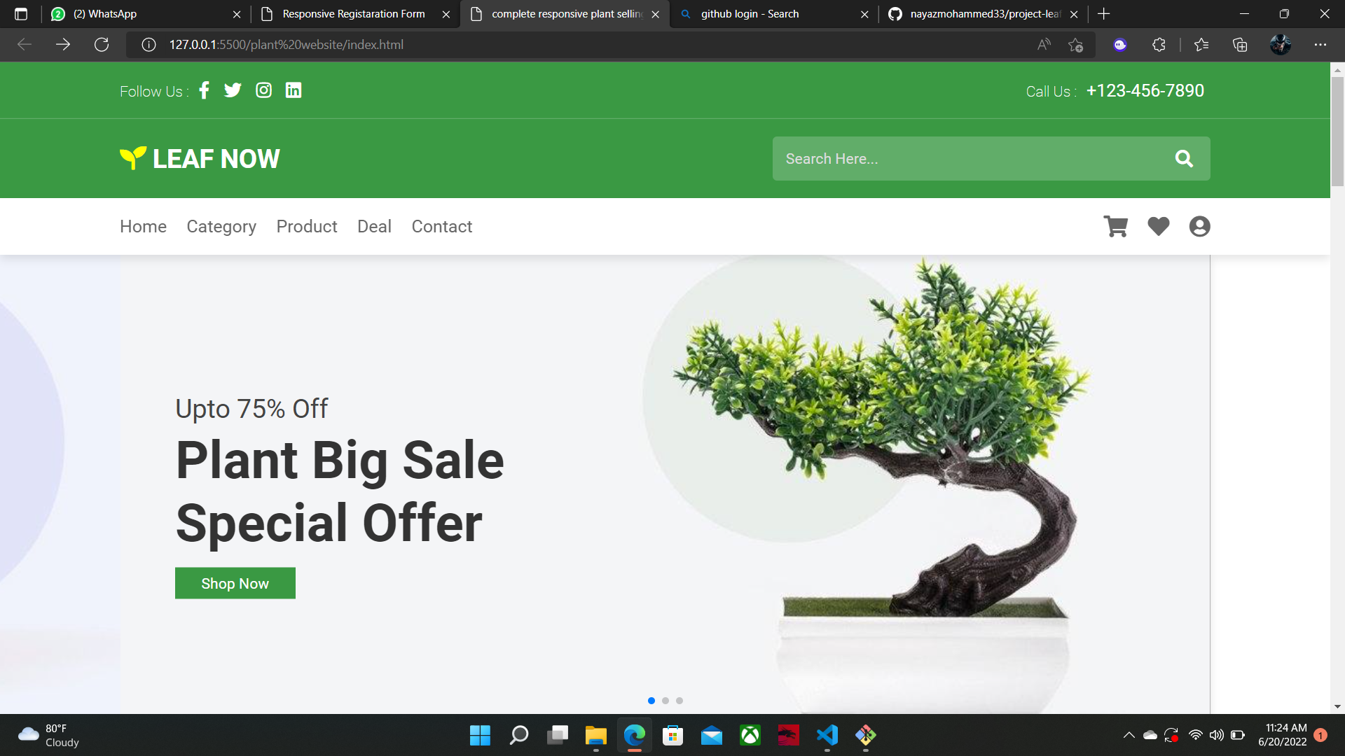

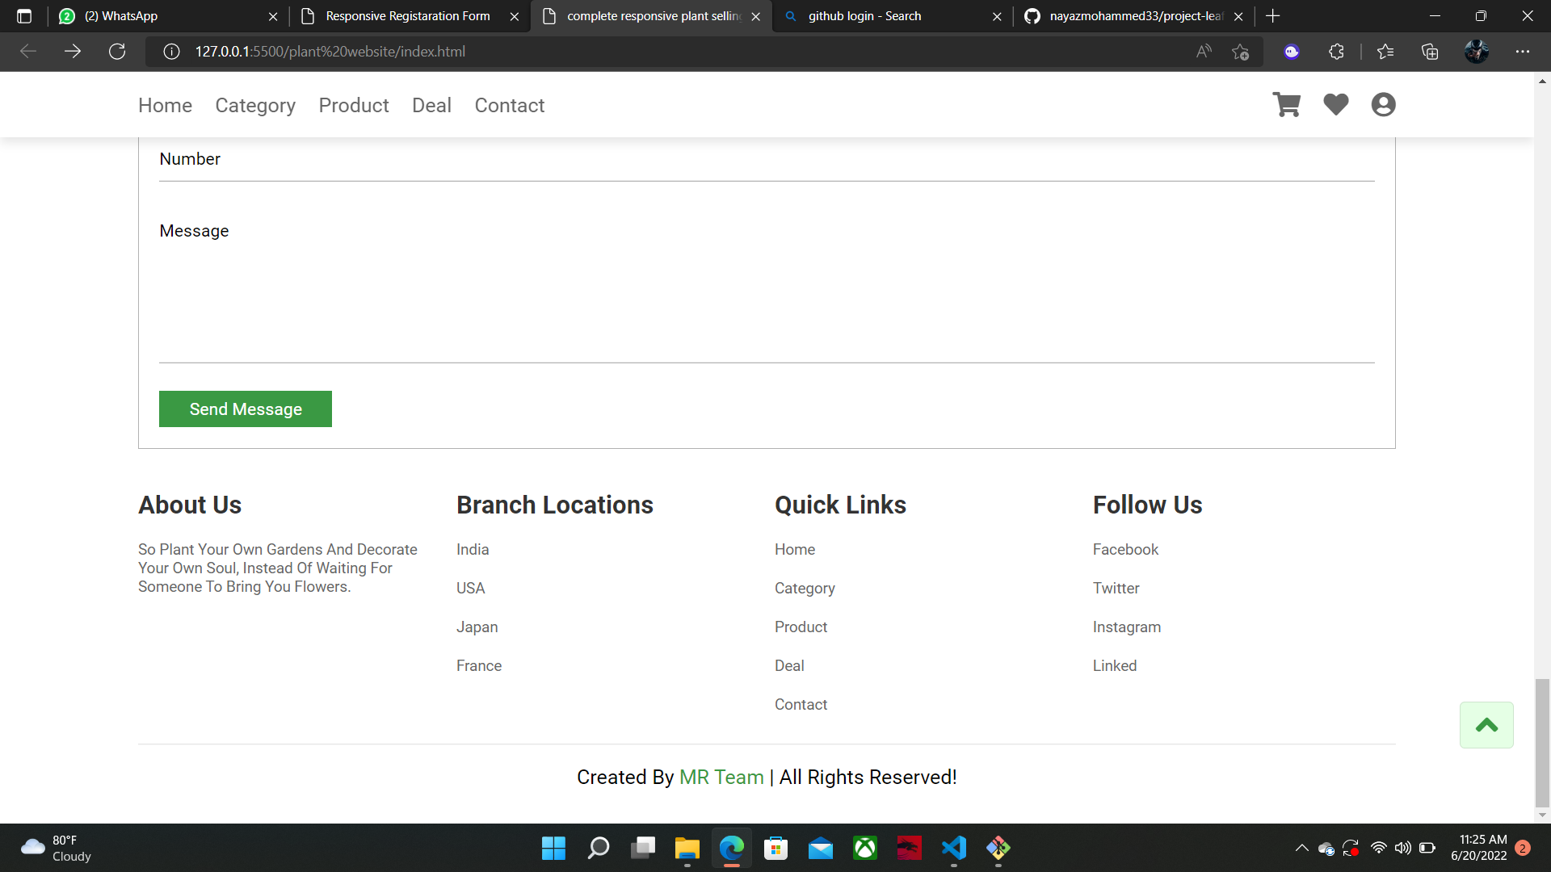

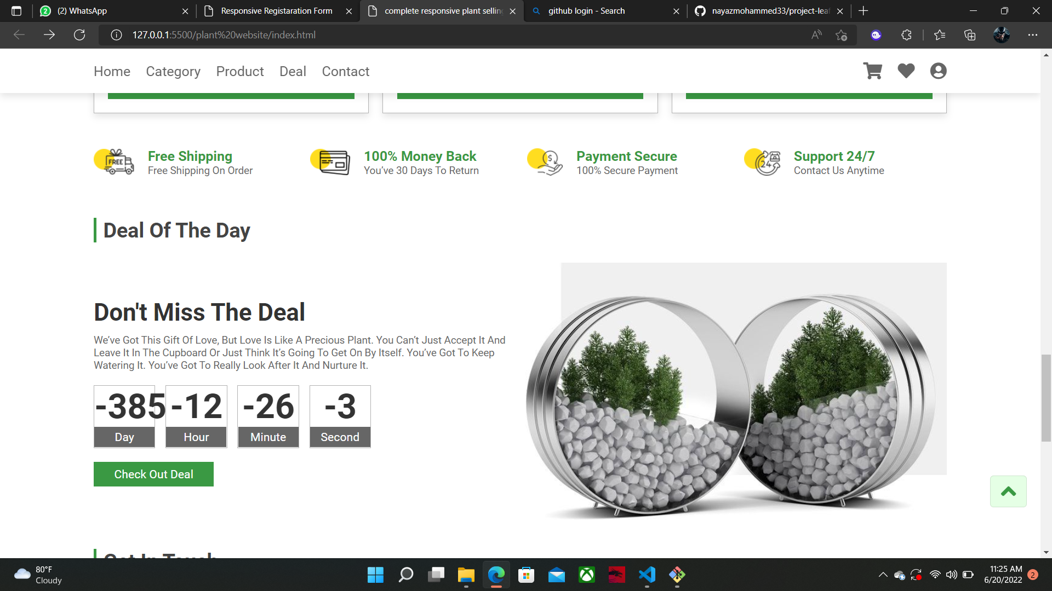

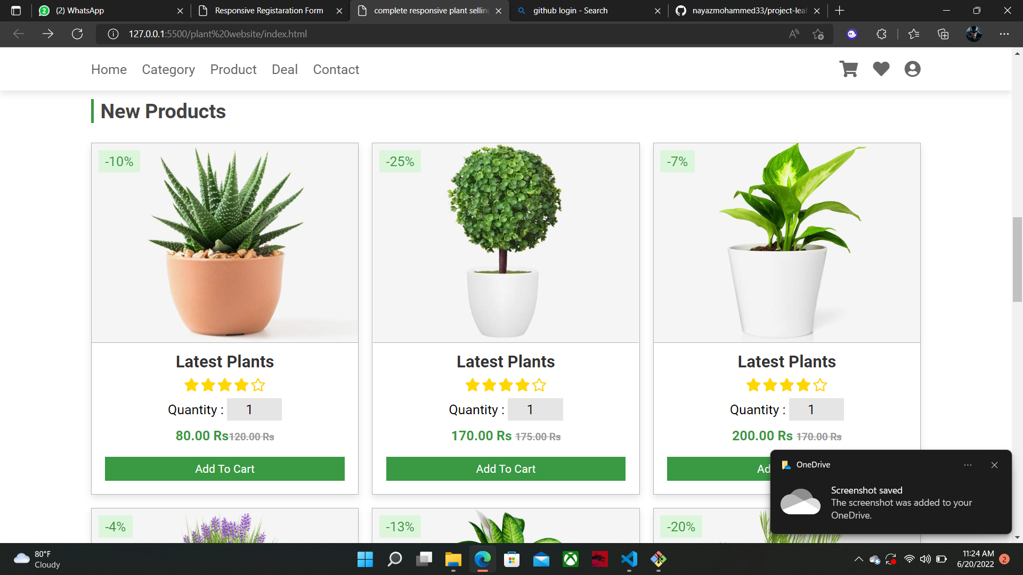

BIBLIOGRAPHY

- https://www.w3schools.com

- https://www.geeksforgeeks org

- https://freefrontend.com

- https://css-tricks.com/

- https://www.takeiteasyengineers.com

- https://dev.to/mychi_darko/php-tips-and-tricks-4kpn

